02nd March 2017

Success for YOKOHAMA at the Geneva Motor Show 2017

Following the launch of new products at Geneva during the Press Days, the Japanese Premium Tyre manufacturer YOKOHAMA concluded a very successful presence at the latest edition of the Geneva Motor Show.

With several World Premieres and European premieres, including the introduction of the BluEarth ES-32, designed to set the all-new standard for a basic tyre while also caring for the environment and boasting fuel saving performance as well as benefitting from YOKOHAMA’s proprietory orange oil technology for enhanced grip, YOKOHAMA also presented the
BluEarth RV-02 exclusively for Crossover SUV and MPVs with excellent wet grip
performance as well as fuel saving, comfort and anti-uneven wear.

In addition to the summer tyres, three new winter products were also introduced such as the BluEarth Winter V905 with enhanced fuel saving performance, the Nordic Stud tyre, iceGuard iG65 offering excellent stud retention and extreme ice performance and meeting Nordic road wear regulation. Another winter tyre launched was the iceGuard studless iG75 for extreme ice braking performance for 4x4/SUVs. Among its other features, the water absorptive compound and directional tread design offers exceptional ice grip with long-life and good fuel saving performance to this tyre.

The 100th anniversary of the company, due in October 2017, was also featured prominently in several areas with a large 100th Anniversary logo placed on the front part of the white flooring of the booth on a corner with a big Y”YOKOHAMA logo next to it. Additionally a visual timeline of significant dates and milestones of the YOKOHAMA ADVAN brand was
created on the base of the display car, which was a red classic Porsche 930 Turbo Cabrio 1989, on loan from the Porsche Museum and which had the A008P (6th Product launched) and which focused on the desire of YOKOHAMA to enter into the Classic Car tyre market.

The Chelsea FC partnership was also highlighted in a purposely designed area of the booth with a large model of a Chelsea FC shirt with the number 100 on the back and Yokohama lettering as name. As a celebration of the partnership and combining with the anniversary, the YOKOHAMA Europe app was also promoted inviting visitors to download the app for the chance to use the interactive features to enter a competition and win prizes. Special promotions were also held throughout the show which also gave visitors the possibility of taking photos with Chelsea FC “Virtual” players at the booth as well as enter into a competition with prizes, via the App’s “Tyre of Fortune”. For more details and to download the YOKOHAMA Europe app please check;

http://www.yokohama-online.com/app

As is traditional the Miss YOKOHAMA was also available for photographs and autographs with guests and the public with YOKOHAMA representatives from Europe and Japan also available to meet and greet the media, business partners and the general public and explain the features and innovative technology in the new products.

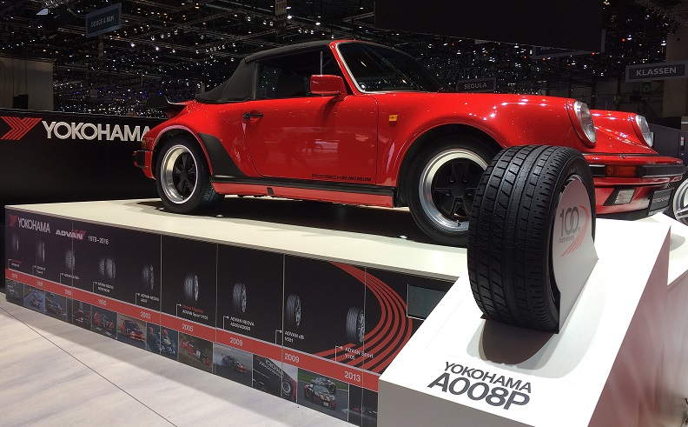
Porsche with YOKOHAMA A008P at Geneva Motor Show 2017

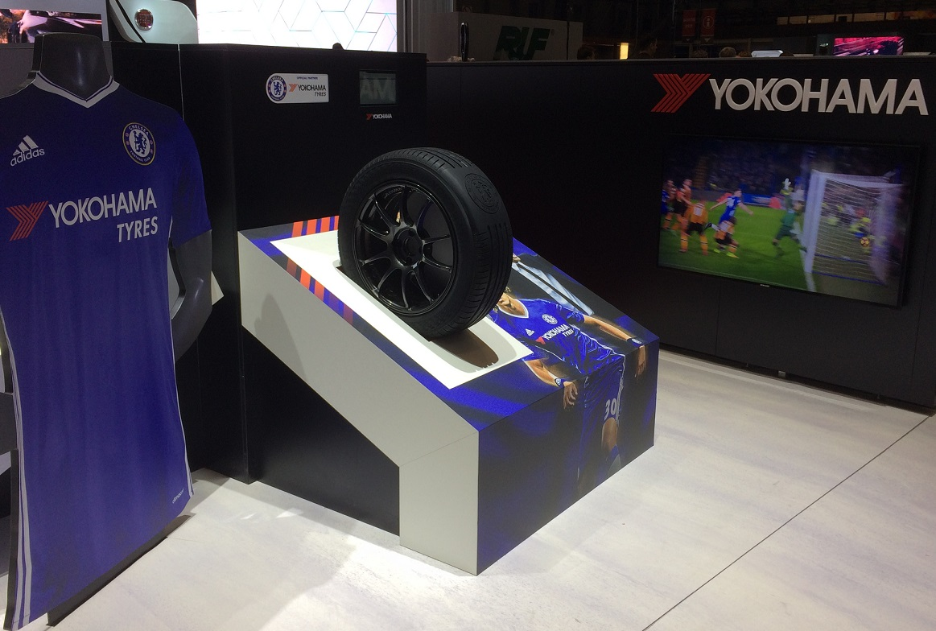
Chelsea FC Corner at YOKOHAMA booth in Geneva 2017

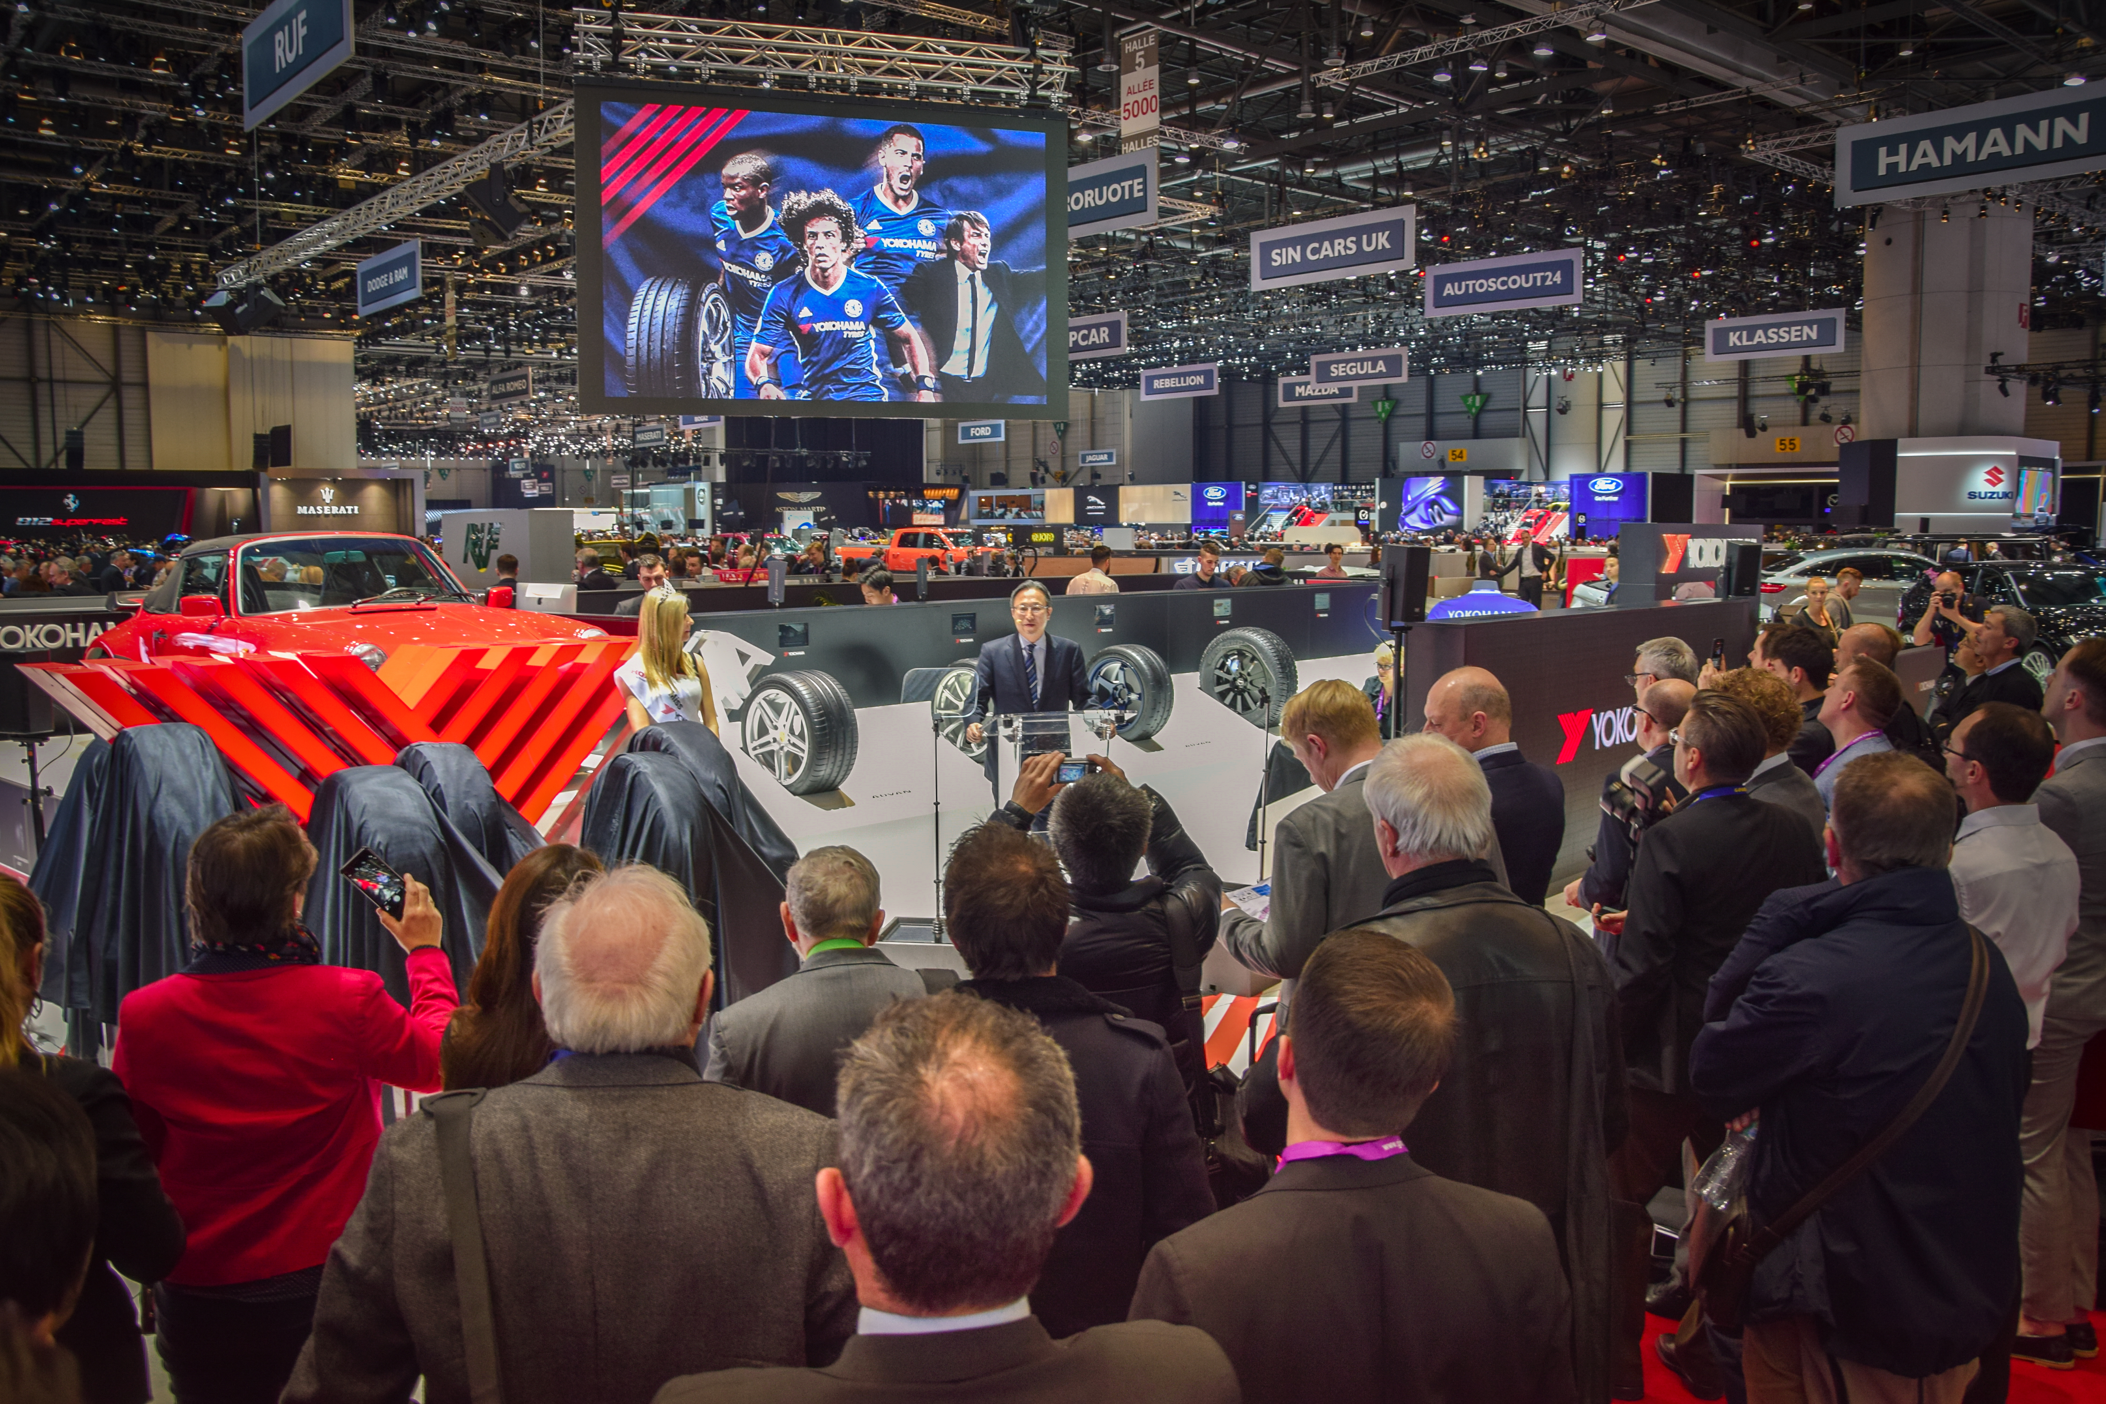
Press Conference Geneva Motor Show 2017 with Corporate Officer Yamamoto san of Yokohama Rubber Company Ltd

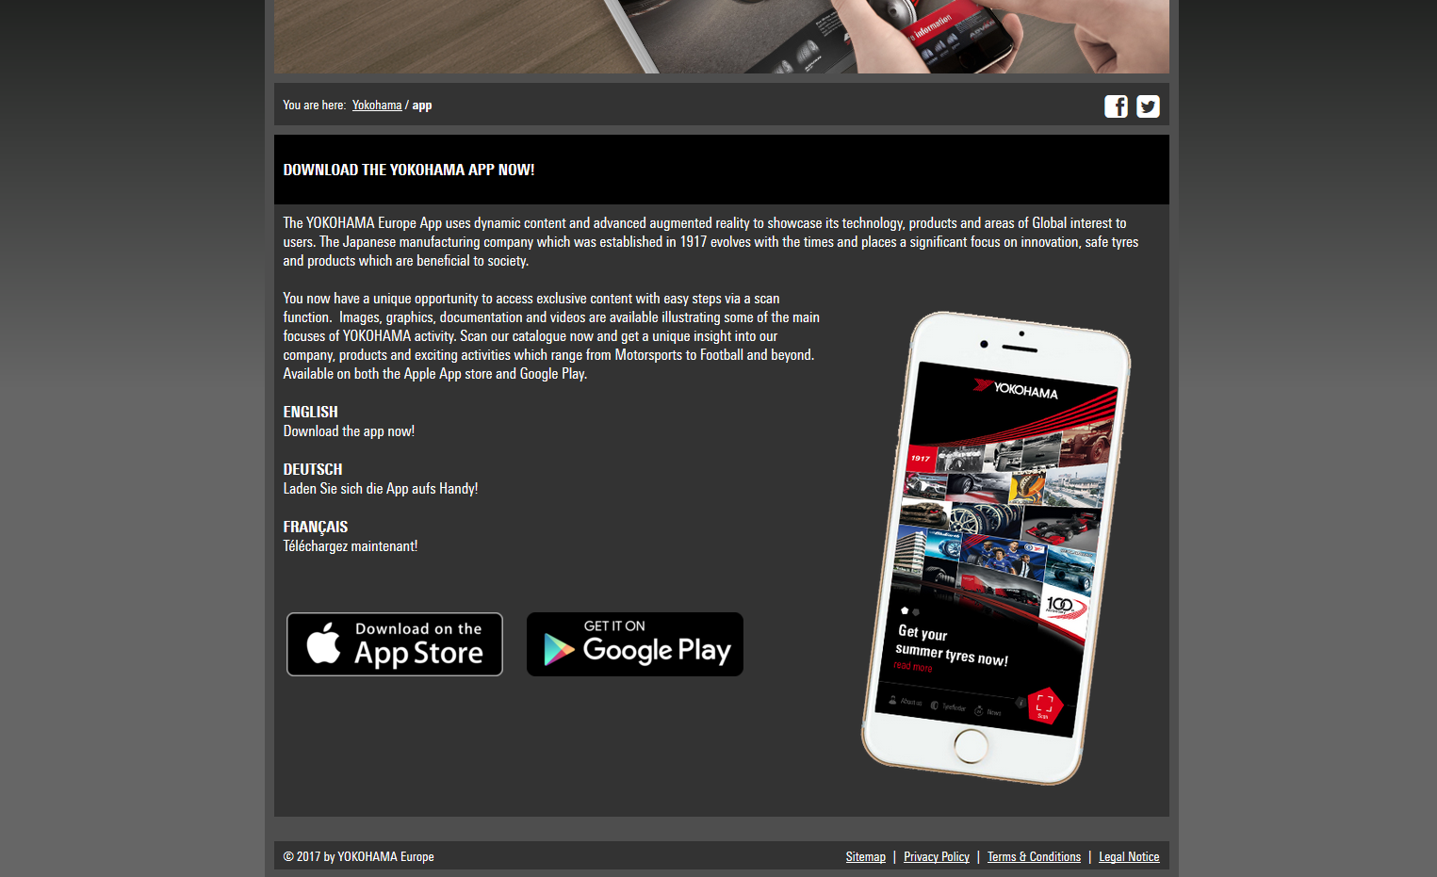
YOKOHAMA Europe App

